W05 Team Activity Designer
Cameron Briggs

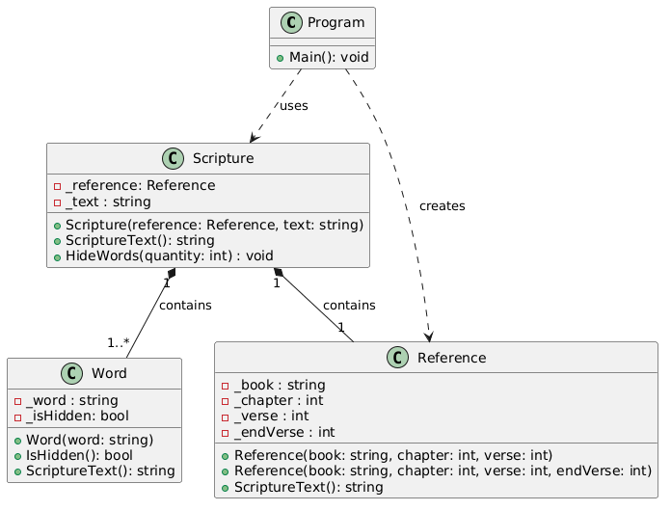

- Each Word object stores its text and boolean visibility. All begin visible and each responsible for displaying either text or underscores.
- Display the scripture reference and text then wait for user input.
- User presses Enter, HideWords() will hide additional words.
- Repeats until user types quit

